**OFFICIAL COORDINATION REQUEST FOR**

**NON-ROUTINE OPERATIONS AND MAINTENANCE**

**Coordination Title:** 16 MCN 08 Debris Spill Notification

**COORDINATION DATE** - May 25, 2016

**PROJECT-** McNary Lock and Dam

**RESPONSE DATE** - June 2, 2016 Revised June 3, 2016

**Description of the problem:**

The surface debris in the forebay is a large mass of woody material which includes many large logs. The amount has not changed substantially since March as the debris volume slightly dissipates and accumulates repeatedly over time. Before the juvenile fish passage season began, a controlled debris spill per 2016 Fish Passage Plan pages MCN-10 and MCN-28, and Debris Spill Notification was planned for the weeks of March 14 and March 23 (Memorandum of Coordination - MOC 16 MCN 02) but the effort was ineffective. With only one spillbay open and the Log Bronc not yet available, the powerhouse flow overcame all efforts to move the debris to the open spillbay. We are requesting an attempt to remove the debris from June 6 to 8 as routine Spring spill is now in progress, TSWs are in place, and the new Log Bronc is operational. TSW closure is to occur on June 8 at 0001 hours. However, if the debris is not completely spilled by June 8, we would like to keep the TSW open in bay 20 until the afternoon of June 9, which will facilitate debris removal. TSW removal requires a second MOC which is pending.

**Type of outage required:**

A generic four unit outage has been coordinated with BPA to support the debris spill. The generic outage is required to allow for flexibility in maintaining debris movement.

**Impact on facility operation:**

If the debris field remains in the forebay, it can settle onto the main unit trash racks, which were recently cleaned the week of May 16. This may result in fish descaling or mortalities, which is not an issue at this time, but could develop when subyearling Chinook begin to out-migrate in substantial numbers.

**Length of time for repairs:**

The time scheduled for the unit outages is from 0800 to 1400 hours. The start time at 0800 hours is due to previous BPA power sales. A tug with a boom will be used to move the debris from the powerhouse to the open spillway along with “rolling” four units off and on to move the debris from south to north. For example, depending on the location of the debris mass, the process may begin with units 1 to 4 out of service. As the debris moves north, units 2 to 5 would be out of service next. Then units 3 to 6 would be out of service and so on until units 11 to 14 are out of service and debris mass is near the spillway. Spill flow may or may not increase during the unit outages. Spill volume will depend on river conditions that day as regulated by RCC.

**Expected impacts on fish passage:**

There should be minimal impact on adult passage. The operation will not be occurring near the adult fishway entrances or exits. Spill patterns will conform with Fish Passage Plan tables. The tables below are generated from the Portland District website:

<http://www.nwp.usace.army.mil/Missions/Environment/Fish/Counts.aspx>

|  |  |  |
| --- | --- | --- |
| Table 1. Running Sum Adult Fish Counts **McNary 5/17/2016 - 5/23/2016** |  | |
| |  |  |  |  |  |  |  |  |  |  |  |  |  | | --- | --- | --- | --- | --- | --- | --- | --- | --- | --- | --- | --- | --- | | **Date** | **All Chinook** | | **Adult Chinook** | | **Jack Chinook** | | **All Steelhead** | | **Clipped Steelhead** | | **Unclipped Steelhead** | | |  | **daily** | **sum** | **daily** | **sum** | **daily** | **sum** | **daily** | **sum** | **daily** | **sum** | **daily** | **sum** | | 5/17/2016 | 2,567 | 2,567 | 2,158 | 2,158 | 409 | 409 | 0 | 0 | 1 | 1 | -1 | -1 | | 5/18/2016 | 2,748 | 5,315 | 2,283 | 4,441 | 465 | 874 | 1 | 1 | 0 | 1 | 1 | 0 | | 5/19/2016 | 2,464 | 7,779 | 2,221 | 6,662 | 243 | 1,117 | -6 | -5 | -1 | 0 | -5 | -5 | | 5/20/2016 | 1,177 | 8,956 | 1,005 | 7,667 | 172 | 1,289 | 0 | -5 | 0 | 0 | 0 | -5 | | 5/21/2016 | 2,071 | 11,027 | 1,813 | 9,480 | 258 | 1,547 | 1 | -4 | 0 | 0 | 1 | -4 | | 5/22/2016 | 2,634 | 13,661 | 2,323 | 11,803 | 311 | 1,858 | 0 | -4 | 0 | 0 | 0 | -4 | | 5/23/2016 | 1,789 | 15,450 | 1,481 | 13,284 | 308 | 2,166 | 3 | -1 | 1 | 1 | 2 | -2 | |  | **daily** | **sum** | **daily** | **sum** | **daily** | **sum** | **daily** | **sum** | **daily** | **sum** | **daily** | **sum** | | **Date** | **All Chinook** | | **Adult Chinook** | | **Jack Chinook** | | **All Steelhead** | | **Clipped Steelhead** | | **Unclipped Steelhead** | | | | |
| Report Run: 5/24/2016 2:24:33 PM Content POC: Fish Field Unit, FFU_Fish_Count_Info@usace.army.mil | | |
| Currently, spring Chinook are the predominant species (Table 1 above) being counted and steelhead kelts are being observed at the JFF separator. Counts from June 2015 (Table 2 below), indicate summer steelhead and sockeye runs will have begun by the time of the scheduled 2016 debris spill. Summer Chinook counts will begin June 9, 2016. Chinook will continue to be the predominant species followed by sockeye. A reduction in powerhouse flow during the debris spill could possibly result in more fallback passage through spill than through the powerhouse. From June 6 to 12, 2015, thirteen adult fallbacks were released from the JFF separator, most of which were non-clipped steelhead.  If units 1 and 2 need to be briefly out of service in order to “roll” the debris, the afternoon outage would least affect adult passage in the Oregon ladder. See Table 3 below. | | |
| Table 2. Running Sum Adult Fish Counts **McNary 6/2/2015 - 6/12/2015** | |  | |
| |  |  |  |  |  |  |  |  |  |  |  |  |  |  |  | | --- | --- | --- | --- | --- | --- | --- | --- | --- | --- | --- | --- | --- | --- | --- | | **Date** | **All Chinook** | | **Adult Chinook** | | **Jack Chinook** | | **All Steelhead** | | **Clipped Steelhead** | | **Unclipped Steelhead** | | **Sockeye** | | |  | **daily** | **sum** | **daily** | **sum** | **daily** | **sum** | **daily** | **sum** | **daily** | **sum** | **daily** | **sum** | **daily** | **sum** | | 6/2/2015 | 1,925 | 1,925 | 1,715 | 1,715 | 210 | 210 | 19 | 19 | 15 | 15 | 4 | 4 | 16 | 16 | | 6/3/2015 | 1,803 | 3,728 | 1,521 | 3,236 | 282 | 492 | 17 | 36 | 14 | 29 | 3 | 7 | 74 | 90 | | 6/4/2015 | 1,577 | 5,305 | 1,410 | 4,646 | 167 | 659 | 20 | 56 | 19 | 48 | 1 | 8 | 83 | 173 | | 6/5/2015 | 1,638 | 6,943 | 1,542 | 6,188 | 96 | 755 | 18 | 74 | 15 | 63 | 3 | 11 | 74 | 247 | | 6/6/2015 | 1,256 | 8,199 | 1,184 | 7,372 | 72 | 827 | 19 | 93 | 18 | 81 | 1 | 12 | 69 | 316 | | 6/7/2015 | 1,025 | 9,224 | 949 | 8,321 | 76 | 903 | 16 | 109 | 14 | 95 | 2 | 14 | 105 | 421 | | 6/8/2015 | 1,299 | 10,523 | 1,215 | 9,536 | 84 | 987 | 24 | 133 | 22 | 117 | 2 | 16 | 216 | 637 | | 6/9/2015 | 1,652 | 12,175 | 1,518 | 11,054 | 134 | 1,121 | 10 | 143 | 12 | 129 | -2 | 14 | 479 | 1,116 | | 6/10/2015 | 1,827 | 14,002 | 1,701 | 12,755 | 126 | 1,247 | 13 | 156 | 9 | 138 | 4 | 18 | 562 | 1,678 | | 6/11/2015 | 1,737 | 15,739 | 1,559 | 14,314 | 178 | 1,425 | 26 | 182 | 26 | 164 | 0 | 18 | 758 | 2,436 | | 6/12/2015 | 2,054 | 17,793 | 1,824 | 16,138 | 230 | 1,655 | 21 | 203 | 19 | 183 | 2 | 20 | 947 | 3,383 | |  | **daily** | **sum** | **daily** | **sum** | **daily** | **sum** | **daily** | **sum** | **daily** | **sum** | **daily** | **sum** | **daily** | **sum** | | **Date** | **All Chinook** | | **Adult Chinook** | | **Jack Chinook** | | **All Steelhead** | | **Clipped Steelhead** | | **Unclipped Steelhead** | | **Sockeye** | | | | | |
| Report Run: 5/24/2016 2:26:23 PM Content POC: Fish Field Unit, FFU_Fish_Count_Info@usace.army.mil | | | |

Table 3. Oregon Ladder Counts June 2 to 12, 2015.

|  |  |  |  |  |  |  |  |
| --- | --- | --- | --- | --- | --- | --- | --- |
| Date | All Chinook | Adult Chinook | Jack Chinook | All Steelhead | Clipped Steelhead | Unclipped Steelhead | Sockeye |
| 6/2/2015 | 965 | 850 | 115 | 6 | 7 | -1 | 11 |
| 6/3/2015 | 1022 | 836 | 186 | 8 | 6 | 2 | 48 |
| 6/4/2015 | 807 | 718 | 89 | 14 | 14 | 0 | 36 |
| 6/5/2015 | 991 | 965 | 26 | 15 | 13 | 2 | 58 |
| 6/6/2015 | 657 | 643 | 14 | 14 | 13 | 1 | 52 |
| 6/7/2015 | 303 | 301 | 2 | 8 | 7 | 1 | 49 |
| 6/8/2015 | 442 | 431 | 11 | 17 | 17 | 0 | 150 |
| 6/9/2015 | 656 | 600 | 56 | 12 | 10 | 2 | 323 |
| 6/10/2015 | 888 | 835 | 53 | 14 | 10 | 4 | 317 |
| 6/11/2015 | 604 | 557 | 47 | 12 | 12 | 0 | 364 |
| 6/12/2015 | 609 | 577 | 32 | 16 | 14 | 2 | 437 |
| **total** | **7944** | **7313** | **631** | **136** | **123** | **13** | **1845** |

Forty percent of the total river flow will continue to be spilled for juvenile fish passage. Expected impact on juvenile fish passage should be minimized by the seasonal timing of the debris spill, which will occur during the daylight hours when fewer juvenile fish are passing through the McNary Dam. Although, the debris will be released through the TSWs, impacts should be negligible. Past juvenile fish out migrations (yearling Chinook, steelhead, coho, and sockeye) have been 90 percent completed (on average) by June 6. Please see Table 4 below for details. This data, provided by McNary PSMFC smolt monitoring program staff, shows juvenile fish facility (JFF) collection data from the past 10 years. All species, including sockeye, typically reach 90 percent or more of total seasonal passage by June 6 to 8.

Relatively few subyearling Chinook will have passed by June 6 - 8. In 2015 only, 3.7 percent of the subyearling Chinook run had passed McNary Dam by June 8. Please see Table 5 below for additional details. This data, also provided by the McNary PSMFC Smolt Monitoring Program staff, supports the expectation that low numbers of subyearling Chinook will be present at the time of the planned debris spill.

Table 4. McNary 10 Average Year 90 Percent Passage Date at JFF.



Table 5. McNary 10 Year Early June Average Passage Subyearling Chinook at JFF.



Please see attached diurnal graphs generated from PIT tag data by provided by PSMFC. This data represents powerhouse passage. Data for diurnal surface and spillway passage is not currently available. The first part of the debris spill will occur just as a powerhouse passage peak for each species has occurred. A percentage of smolts that would have pass through the powerhouse may be guided north to the spillway and TSWs. Both of which are considered better passage routes except the TSW for subyearling Chinook, which swim deeper than the other species. Counts at the JFF by species for 2015 during the time frame of the 2016 debris spill are recorded in Table 6 below. The spill should occur after most species have out migrated as stated above and prior to the arrival of most subyearling Chinook.

Table 6. McNary JFF Passage June 2 to 12, 2015.

|  |  |  |  |  |  |  |
| --- | --- | --- | --- | --- | --- | --- |
| Date | Yearling CH | Sub-Yr CH | Clipped SH | Non-clipped SH | Sockeye | Coho |
| Jun 2 | 3,643 | 3,668 | 624 | 615 | 1,300 | 1,200 |
| Jun 4 | 2,814 | 2,119 | 859 | 358 | 600 | 800 |
| Jun 6 | 2,400 | 6,200 | 1,250 | 550 | 550 | 600 |
| Jun 8 | 1,700 | 7,750 | 1,400 | 250 | 300 | 1,150 |
| Jun 10 | 1,874 | 15,559 | 1,110 | 457 | 150 | 850 |
| Jun 12 | 1,011 | 28,985 | 103 | 101 | 0 | 100 |

2006 – 2015 Diel Juvenile Fish PIT Tag Detections April 1st - September 30th

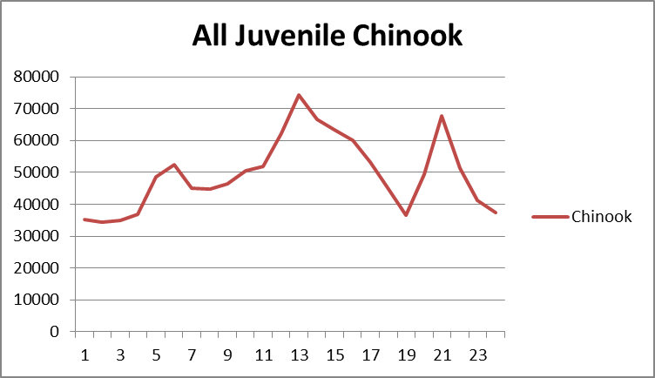 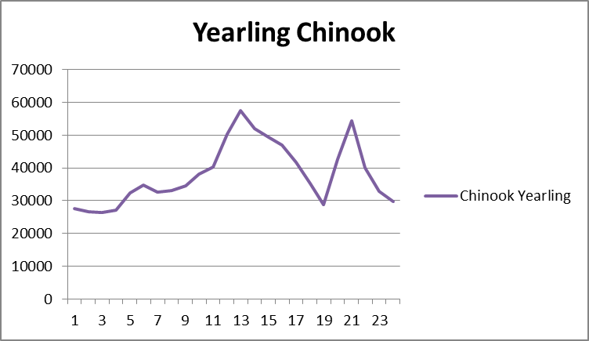

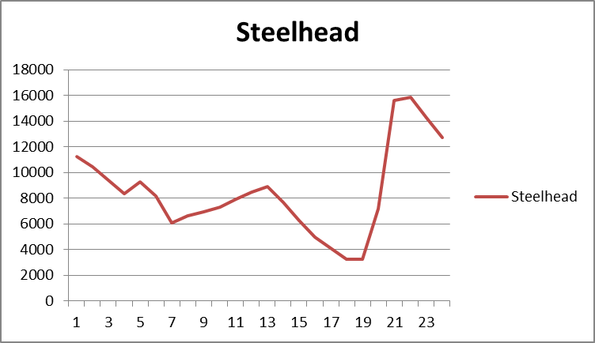 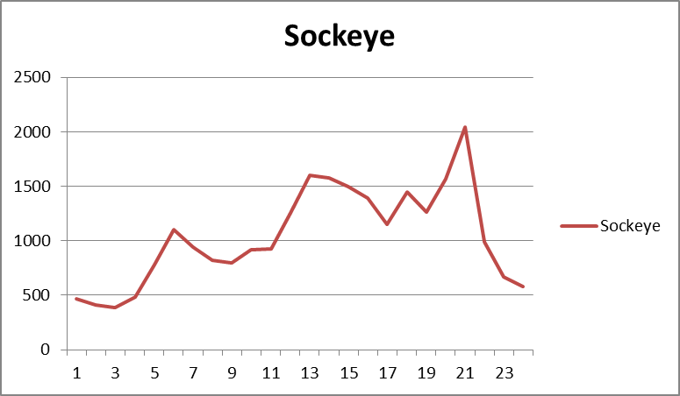

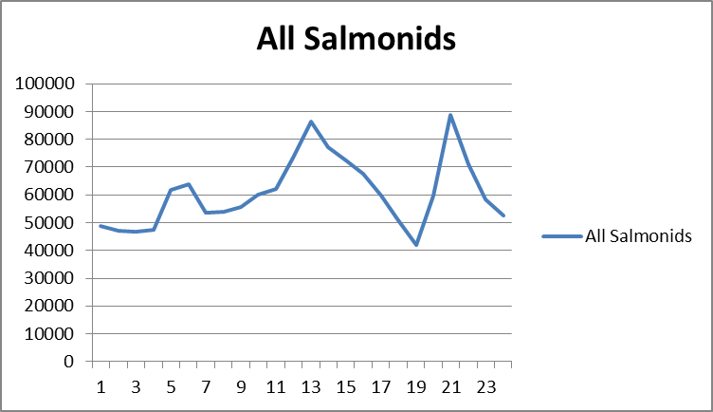

2006 – 2015 Diel Juvenile Fish PIT Tag Detections May 1st – 31st.

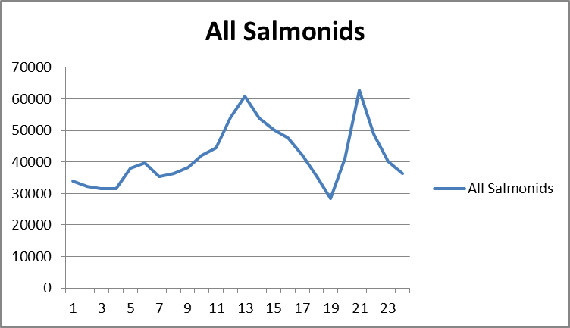 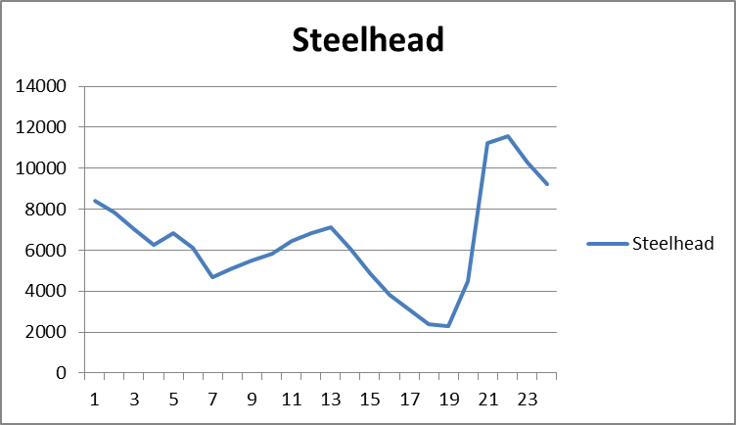

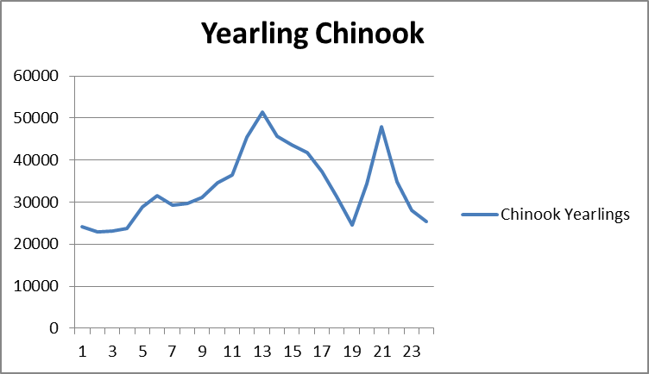 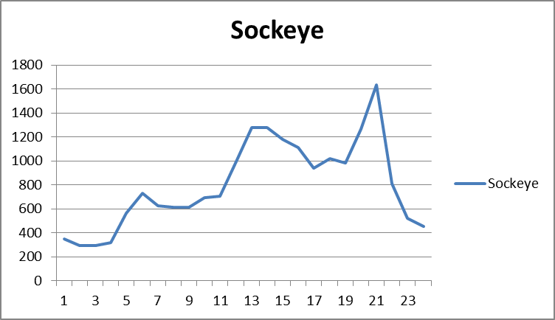

**Comments from agencies**

Comments are requested by the close of business on June 2.

-----Original Message-----  
From: Morrill, Charles (DFW) [mailto:Charles.Morrill@dfw.wa.gov]   
Sent: Wednesday, May 25, 2016 10:30 AM  
Subject: [EXTERNAL] RE: MOC 16 MCN 08 Debris Spill Notification

Hi John,

WDFW is ok with this request

Charlie

-----Original Message-----  
From: Gary Fredricks - NOAA Federal [mailto:gary.fredricks@noaa.gov]   
Sent: Wednesday, June 01, 2016 11:35 AM  
To: Bailey, John C NWW <John.C.Bailey@usace.army.mil>  
Cc: Johnson, Bobby NWW <Bobby.Johnson@usace.army.mil>  
Subject: [EXTERNAL] Re: MOC 16 MCN 08 Debris Spill Notification

John, This looks ok to me. Yearling numbers are dropping and subs are just starting to pick up. Adult passage is fairly low as well so I don't think there will be much impact on fish passage from the activity. Thanks to you and Bobby for the thorough MOC. Gary

**Final results**

Please email or call with questions or concerns.

Thank you,

Bobby Johnson

Project Fishery Biologist, McNary Dam

Phone: (541)-922-2212

Email: [bobby.johnson@usace.army.mil](mailto:bobby.johnson@usace.army.mil)